

Eidoo — April Earned Media Article #2

13 May 2021

Prepared by AmaZix

NFTs — The Most Comprehensive Guide

  
https://freerangestock.com/sample/92071/exit-maze-showing-puzzle-way-out.jpg

Usually, when we hear about crypto in the news, it is not for good. That happened lately worldwide with NFTs right after the 137th announcement of the death of Bitcoin.

*Non-fungible assets are just normal stuff. Fungible assets are the odd ones out!*

Devin Finzer, CEO and co-founder of [OpenSea.io](https://opensea.io)

As everybody already knows by now, NFT stands for Non-Fungible Tokens and, from a market perspective, very simply put, because there is really no reason to complicate things further, if you set something apart and it retains a proportional value of the something left, then it is fungible. Otherwise, you broke it, my friend, it was non-fungible.

Was it a driller? The first picture of Vitalik doing “blockchainy” things? Well, now it is no more.

We will get back to that idea but the concept is that simple when you take it out of the classical gold ingot example. That makes most of the things in our lives non-fungible, NCLUD NG MY KEYBOARD W TH A M SS NG LETTER “ “.

See? Non-fungible.

Non-fungible tokens are representations of such kinds of assets that have opened a whole new world of possibilities. Let’s explore how NFT makes the concept more powerful by looking at its characteristics.

# The Properties of NFTs

As currently defined, NFTs have the following properties, as mentioned in the [Non-Fungible Token Bible](https://opensea.io/blog/guides/non-fungible-tokens/).

* **Standardization**: The format in which an NFT comes defined is standard, so any platform supporting it can access the information related to that asset. This property prevents the asset from being constrained to a single domain, thus making it reusable or inheritable in other places.
* **Interoperability**: The definition of non-fungible tokens and changes of parameters may also be valid and understood beyond the place where it was first created. Parameters such as ownership, transfers, or access rights, for instance. Also, the changes related to the asset can be checked by anyone.
* **Tradeability**: This frees any item from the dependence of having to be sold in certain specialized places. With all the related information accessible, anyone can sell an NFT in any compatible market.
* **Liquidity**: Sites that offer a market for more types of items attract a greater number of interested parties, expanding the potential demand for any type of asset and increasing its liquidity.
* **Immutability**: Non-fungible tokens live on a blockchain. There is no need to belabor this point, is it?
* **Programmability**: With this last property, our heads can spin, imagining the possibilities it provides, right?

# NFT Standards

Well, the time has come to talk about numbers, ERC numbers — and we all know the number 20 that blesses our crypto wallets with precious, and not so precious, tokens.

NFTs however are defined in the ERC721 standard. We are referring to pure **non-fungible** asset tokens.

Let us return for a moment to the above definition of this idea. Value is the key aspect of fungibility for NFTs, not to be confused with the non-fungible price.

*"Price is what you pay; value is what you get."* - Warren Buffet

In addition to the aforementioned physical integrity of a given asset, its market value can be affected by the assigned emotional component, its useful life, or the time we can make use of it in a time-sharing regime.

  
https://simpsons.fandom.com/wiki/Dead_Putting_Society?file=Homerandflanders.jpg

These types of uses refer to **semi-fungible** assets and are defined in the ERC-1155 standard. It introduces classes that may include items sharing some set of parameters that define them.

As you might guess, this brings us to a small drawback. New standards may require new wallets which would force us to have to use more applications.

Fortunately, the DeFi industry is always vigilant and has already created solutions like the folks at [Eidoo](https://eidoo.io/) that integrate a non-fungible token Manager within the same ERC20 wallet application. So, no more passwords to remember, forget or repeat — just the one for accessing your crypto wallet.

What is really important is to keep the distinction between the two cases — non-fungible and semi-fungible — because that is where the magic happens.

# Using NFTs

As it appeared in the news recently, the most scandalous and evident use has been that of digital assets of particular relevance and cuteness, also known as Crypto Kitties.

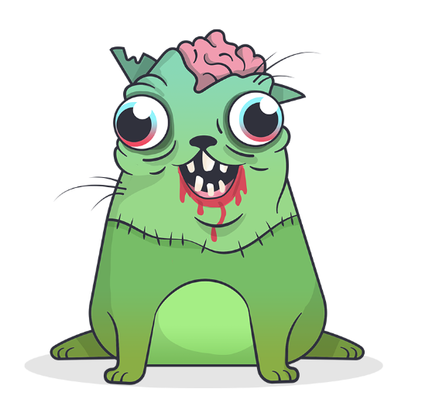

https://www.pngwing.com/en/free-png-meqms

crypto kitty not feeling fungible

But let's be rigorous and ask ourselves what's so interesting about the non-fungible Crypto Kitties?

The truth is that they demonstrated the power behind non-fungible tokens by integrating their lovely parameters on the metadata, defining them univocally to create an NFT that represented each kitty without any possibility of error.

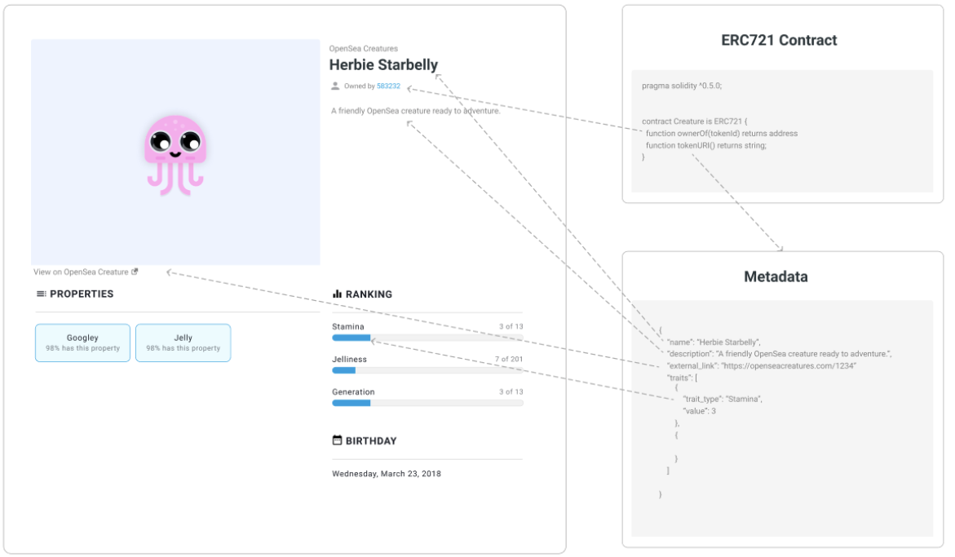

Source: [OpenSea Blog](https://opensea.io/blog/guides/non-fungible-tokens/#Off-chain_Metadata)

Beyond sensationalism, the truth is that the NFTs have had a way beyond, reaching the world of collectibles. This type of item has already benefited from an important development with the appearance of the Internet and social networks and could be about to live a golden age thanks to an ERC document.

Art is another type of asset ideal to make use of a non-fungible token format. At this point, art is constrained to the supported format requirements (JPG and PNG), but as things develop, we might see other formats or techniques. Who knows, maybe the return of steganography on image, music, and video integrated with viewers and players.

Furthermore, a particularly interesting, almost natural, use of NFTs has been seen in the gaming world. Quickly, the sharp minds in the MMORPG industry saw the possibility of defining assets and metadata (both their characteristics and their cool names) as tokens so that ownership would be better represented to the community.

In essence, non-fungible tokens are inherited assets to be grouped and sold with parent assets. In other words, if you transfer the ownership of a character, not only game perks but also its NFT-registered assets will go with it.

# NFT Possibilities

So far, we have mentioned the most obvious use cases, but what other fields could be opening up already?

In general, any product where provenance is a key component of its value may be a viable candidate to enter the market as a non-fungible token. These types of products usually have to be backed by certificates and the sites that sell them act as auditors and guarantors of the veracity of the item. But, hey, that's what the blockchain with its immaculate transparency is for.

Products that are more commercial than unique pieces but try to retain a certain aspect of exclusivity due to their branding or limited editions are also very NFT-able.

However, this is not going to happen. Because it is already happening. Exclusivity is the ultimate concept that fits in the non-fungible token catalog. Either you have it or you don’t.

There are already initiatives that point in this direction on the part of the National Basketball Association (NBA), National Football League (NFL), Ultimate Fighting Championship (UFC), Formula 1, Louis Vuitton, Samsung, and Nike.

NFTs could become the next big thing in the crypto ecosystem. In addition to their suitability for traditional assets, the inclusion of classes with ERC1155 makes it possible to speculate about new types of non-fungible tokens applied to DeFi, derivative products, insurance, e-identity, last wills, etc.

It is difficult to predict with certainty where the innovation will go but it is certainly something that goes beyond the interest of digital cat owners.